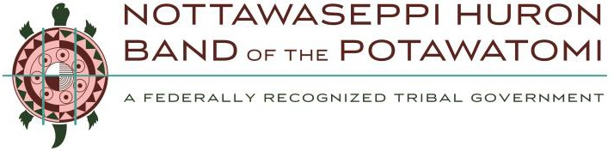
In order for your donation request to be considered, this application form must be completed in full and submitted via email or regular mail to:

General Information
Robyn Burlingham, NHBP Tribal Council Coordinator 1485 Mno-Bmadzewen Way, Fulton, MI 49052
Fax: 269-704-8582, Email: rburlingham@nhbpi.com

Date of Application:

Name of Organization:

Street Address (No PO Boxes):

City:
State:
Zip:

Contact Person:
Title:
Phone:

Email Address: Non-Profit Federal Tax I.D. Number:

Amount Requested: Overall Cost of your Event/Project/Campaign:

Has your organization ever received support from NHBP for this Event/Project/Campaign in the past?

Donation Request Information
  - State your Organization’s Mission:

  - Give a brief (50 words or less) summary of your program (including name, dates, and location if applicable) and the reason for this donation request:

  - State other information that will assist in a favorable decision on behalf of this function or provide additional information about additional non-monetary requests (i.e., land, building use, etc). Use a separate page if necessary and attach to this application.

  - Describe how your program would benefit the NHBP Tribe’s Community and the surrounding area (be as specific as possible):

  - If approved, who does the Tribe make the check payable to?

Provide mailing address where donation is to be sent

  - Please attach copies of the following (required):
    - Your organization’s 501(c)3 or letter of determination from the IRS
    - A copy of your W-9 form, signed
    - Annual Report (upon request)
    - Optional: any other documentation you feel would be beneficial for your request

Failure to submit all documents requested will delay your application.
All applications are reviewed on a monthly basis.
The Nottawaseppi Huron Band of the Potawatomi Tribal Council reserves the right to request copies of your organizations financial statement for the previous three (3) years.

3. Applicant Signature Required:
I attest that the information provided is true and correct to the best of my knowledge and that any false information provided may disqualify my application for funding. I understand these funds are to be used to help promote the Tribe, its community, and its members.

Signature of Applicant and/or Parent/Legal Guardian Date

FOR OFFICIAL USE ONLY
Date Presented to Nottawaseppi Huron Band of the Potawatomi (NHBP):

Decision of the NHBP:
Approved
Denied

Amount and/or Type of Donation Approved:

